## Week 2 - Regression

1. Which figure represents an overfitted model?

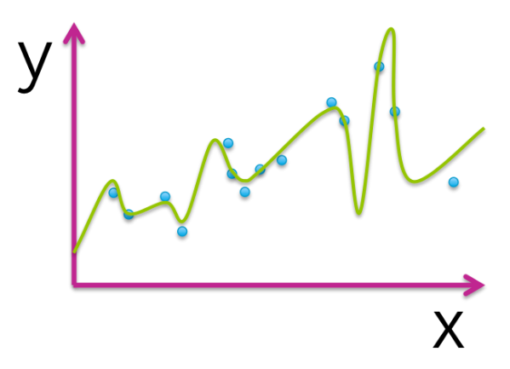

1. True or false: The model that best minimizes training error is the one that will perform best for the task of prediction on new data.
   1. False
2. The following table illustrates the results of evaluating 4 models with different parameter choices on some data set. Which of the following models fits this data the best?

|  |  |  |
| --- | --- | --- |
| Model index | Parameters (intercept, slope) | Residual sum of squares (RSS) |
| 1 | 0, 1.4 | 20.51 |
| 2 | 3.1, 1.4 | 15.23 |
| 3 | 2.7, 1.9 | 13.67 |
| 4 | 0, 2.3 | 18.99 |

1. Model 3
2. Assume we fit the following quadratic function: f(x) = w0+w1*x+w2*(x^2) to the dataset shown (blue circles). The fitted function is shown by the green curve in the picture below. Out of the 3 parameters of the fitted function (w0, w1, w2), which ones are estimated to be 0?

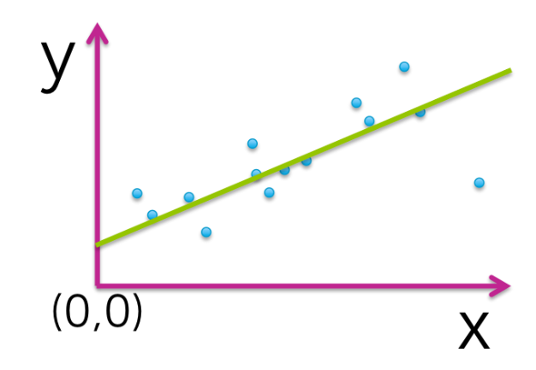

* 1. w2

1. Assume we fit the following quadratic function: f(x) = w0+w1*x+w2*(x^2) to the dataset shown (blue circles). The fitted function is shown by the green curve in the picture below. Out of the 3 parameters of the fitted function (w0, w1, w2), which ones are estimated to be 0?

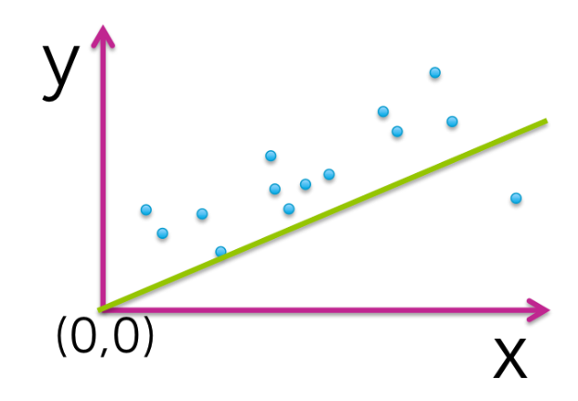

* 1. w0
  2. w2

1. Assume we fit the following quadratic function: f(x) = w0+w1*x+w2*(x^2) to the dataset shown (blue circles). The fitted function is shown by the green curve in the picture below. Out of the 3 parameters of the fitted function (w0, w1, w2), which ones are estimated to be 0?

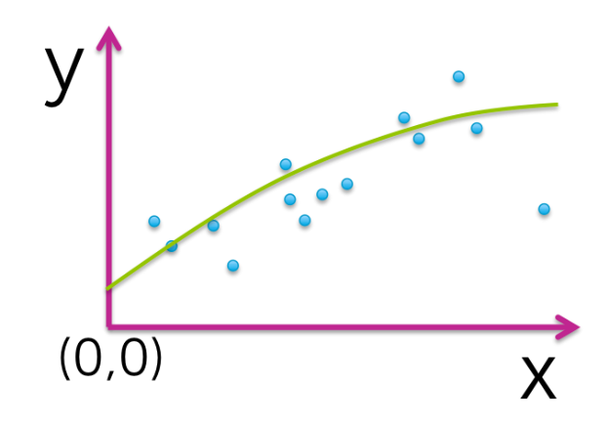

* 1. None of them

1. Assume we fit the following quadratic function: f(x) = w0+w1*x+w2*(x^2) to the dataset shown (blue circles). The fitted function is shown by the green curve in the picture below. Out of the 3 parameters of the fitted function (w0, w1, w2), which ones are estimated to be 0?

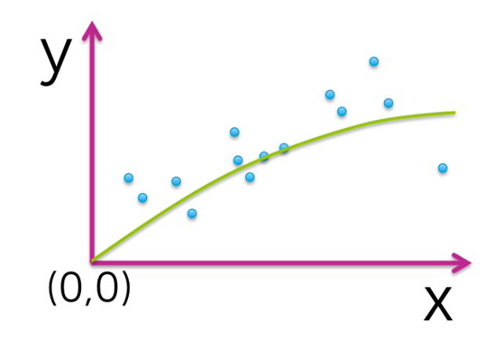

* 1. w0

1. Which of the following plots would you not expect to see as a plot of training and test error curves?
   1. 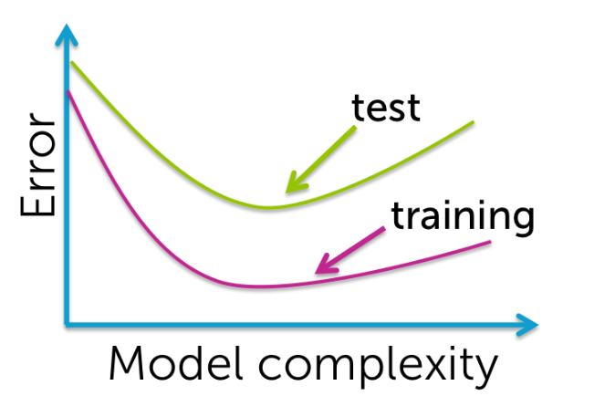
2. True or false: One always prefers to use a model with more features since it better captures the true underlying process.
   1. False

## Week 3 – Classification